<https://wnyt.com/stem-13/ualbany-students-prepare-for-competition-to-help-people-with-disabilities/>

<https://spotlightnews.com/news/2023/04/19/inclusive-innovations-break-down-barriers/>

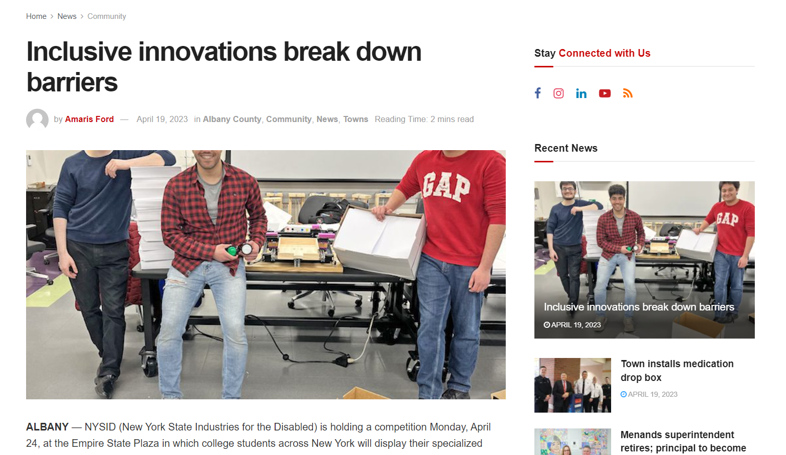

<https://wnyt.com/top-stories/ualbany-students-win-big-in-science-symposium/>

